**Chapter 3**

This chapter will mainly focus on the design and implementation of the main character’s actions and responses. The chapter will also give details on the level’s design and descriptions on how each interactive object and environment will react in accordance to the main character’s interaction. Lastly, details of the Oculus virtual reality control scheme changes and implementation will be discussed.

The main character navigates through levels with the aid of the player controlling the secondary character. Throughout the game’s levels, the main character will often come across multiple types of environmental and enemy obstacles. The character will then make decisions based on what’s called an “A.I. push” system, which is a system that makes the A.I. spend its time calculating the best choices among the choices given in the game. When the A.I. finally makes its decision, the result is broadcasted to any entity involved. This type of system is isolated and acts independently of the games own architecture. An example of this would be a situation where the A.I. character would be engaged with an enemy and the character becomes low on health, he has the option to continue fighting, use a speed potion, or to restore his health, and he uses the A.I. push system to calculate the best option to take to maximize chances for victory. The clearest option will not be obvious to the A.I. initially, but the A.I. character will eventually become aware of the best choices after failed attempts or help from the player.

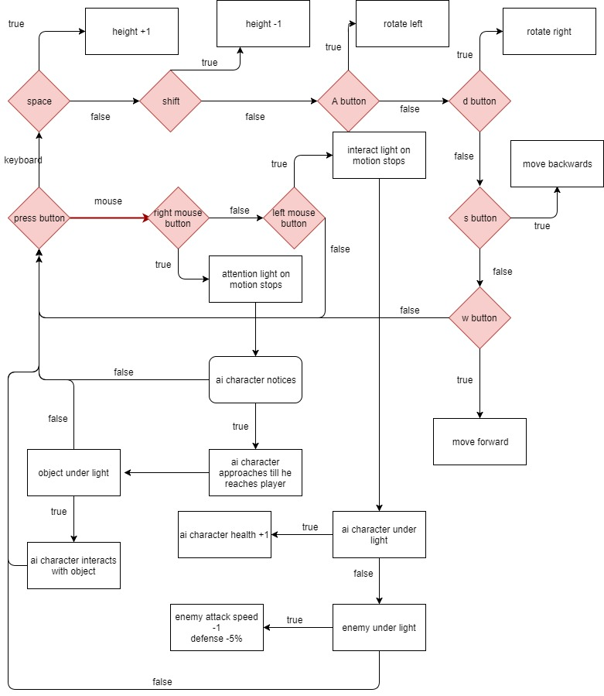

For the level design, a height map of a real island was downloaded and integrated by using photoshop in order to change the default setting of the height map to use in unity. High resolution textures models for ambient objects such as rocks and trees were also used in the same manner. These trees and rocks will be able to be mined by the main character, allowing the player to craft new objects or weapons. There will also be lakes and rivers in the environment that the main character may need to cross, and if the player and A.I. character have not beaten the boss that gives the A.I. character the ability to swim, the character will drown. The levels will also have various traps meticulously placed throughout the stages. Examples of this are whenever the A.I. character steps on a trigger on the floor, a trap door in the floor or on the wall opens and releases poison gas, damaging the player. Another trap would activate if the character opens the wrong door, releasing a large number of enemies, or activating a tripwire releases a trapdoor that unleashes arrows or cannon shots. At the end of every level there will be a large gate that can only be able to be unlocked by a key held by a boss character.

In the Oculus VR version, the game will be played in a top-down, isometric view where the player moves via teleportation method, which is a control scheme where the player aims a beacon of light at a desired area with the controller’s analog stick and releases the stick to teleport to that location, as shown in the image below. This method of moving will be used because as of today, the walking method of movement that’s traditionally used in games has yet to be properly configured and gives most users motion sickness, therefore teleportation would be a safer, more convenient method. The player will have the option to use a standard Xbox One controller or the more innovative Oculus Touch controller, where the player could use the controller to simply point in a direction to guide the A.I. character towards a corresponding object or into battle and pressing a button confirm the direction and have the character move there.

